Read Aloud #4

Kevin the Unicorn, It’s not All Rainbows
Written & illustrated by Jessika von Innerebner

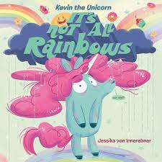

Extension Ideas: Be an author and illustrator like Jessika von Innerebner!

- Create your own unicorn and draw a picture of what it looks like. What colour is your unicorn? What is your unicorns hair/mane like? What is your unicorns name? How is your unicorn feeling today?

- Write a story about an adventure that your unicorn goes on, or what a typical day is like for your unicorn.

- Check out Jessica von Innerebner’s website for some fun activities related to our story in her series “At home with Kevin the Unicorn.” http://www.jessvoni.com/at-home-with-kevin-the-unicorn

